HANOI UNIVERSITY OF SCIENCE AND TECHNOLOGY

School of Information and Communications Technology

ITSS Software Development Report

**EcoBikeRental**

Subject: Software Development

Instructor: Prof. Trinh Tuan Dat

Student: Tran Hai Son - 20176861

*Hanoi, December 2020*

1. Assigned Use Case

|  |  |  |  |
| --- | --- | --- | --- |
| **Use case code** | UC001 | **Use case name** | Insert credit card |
| **Actor** | User | | |
| **Precondition** | User must be in docking station before renting bike | | |
| **Main flow of event**  **(success)** | |  |  |  | | --- | --- | --- | | No | Doer | Action | | 1. | User | Press "Rent" button. | | 2. | System | Display dialog to enter card number. | | 3. | User | Enter card number (description below *). | | 4. | User | Request for bike (press confirm button). | | 5. | System | Check if card number is valid or not. | | 6. | System | Check if credit card is available or not. | | 7. | System | Check if credit card has enough money to perform transaction or not. | | 8. | System | Prompt user and move to another screen to show state when renting bike. | | | |
| **Alternative flow of event** | |  |  |  | | --- | --- | --- | | No | Doer | Action | | 5a. | System | Error: card number is invalid. | | 6a. | System | Error: credit card is being used to rent bike. | | 7a. | System | Error: credit card does not have enough money to perform transaction. | | | |

* Bike code requirement.

|  |  |  |  |  |  |
| --- | --- | --- | --- | --- | --- |
| No | Input | Description | Compulsory? | Valid condition | Example |
| 1. | Card number | User must enter credit card to rent bike, 1 credit card is allowed to rent only 1 bike at a time. | Yes | Card number must be same with valid code in the system | 201768612017 |

1. Diagrams
   1. Sequence Diagram for Analysis Class

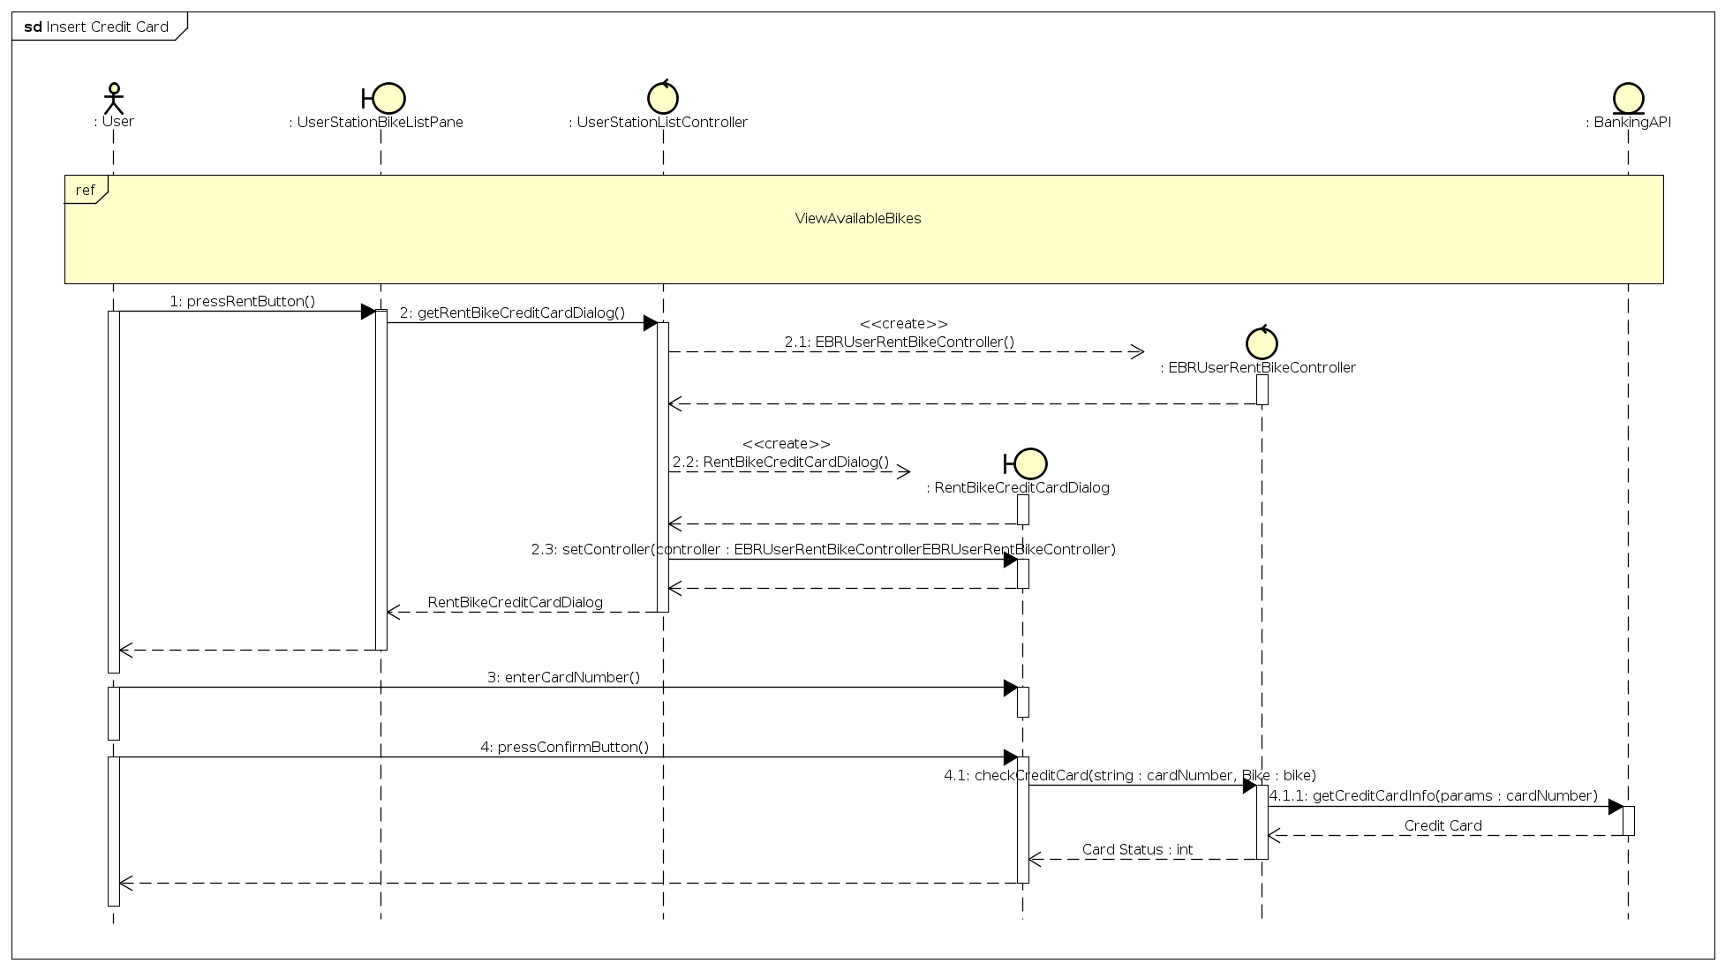

* 1. Analysis Classes

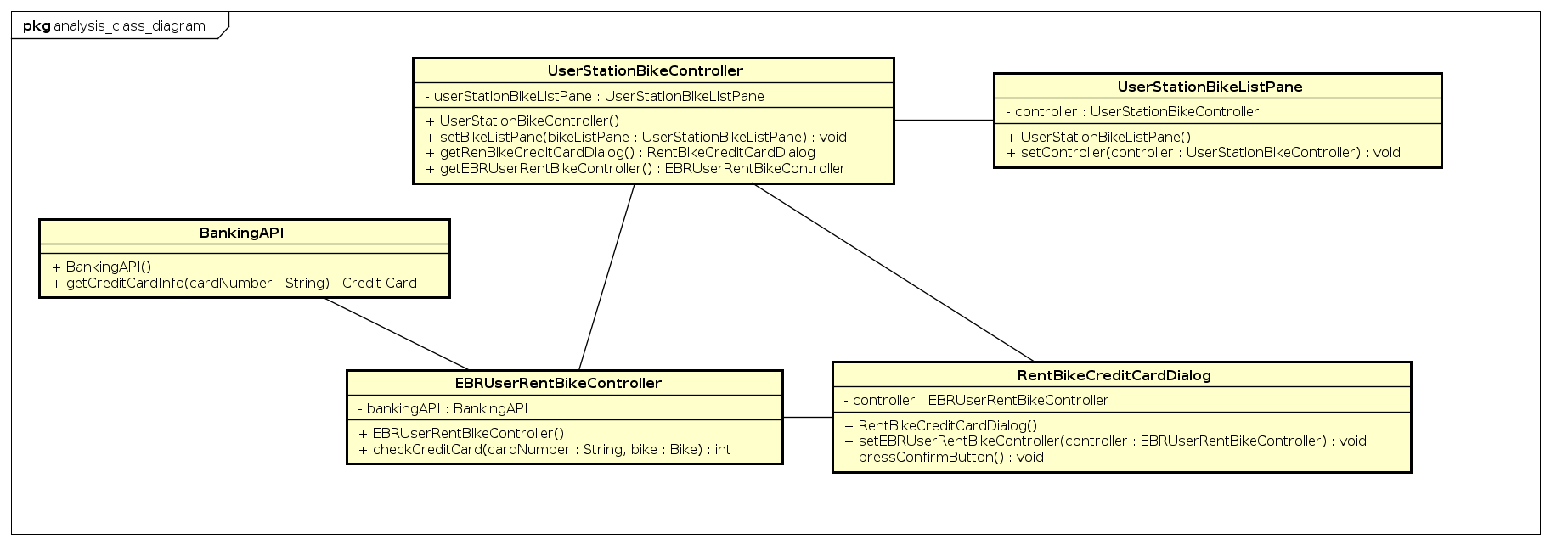

* 1. Package Diagram

* 1. Sequence Diagram for Design Class

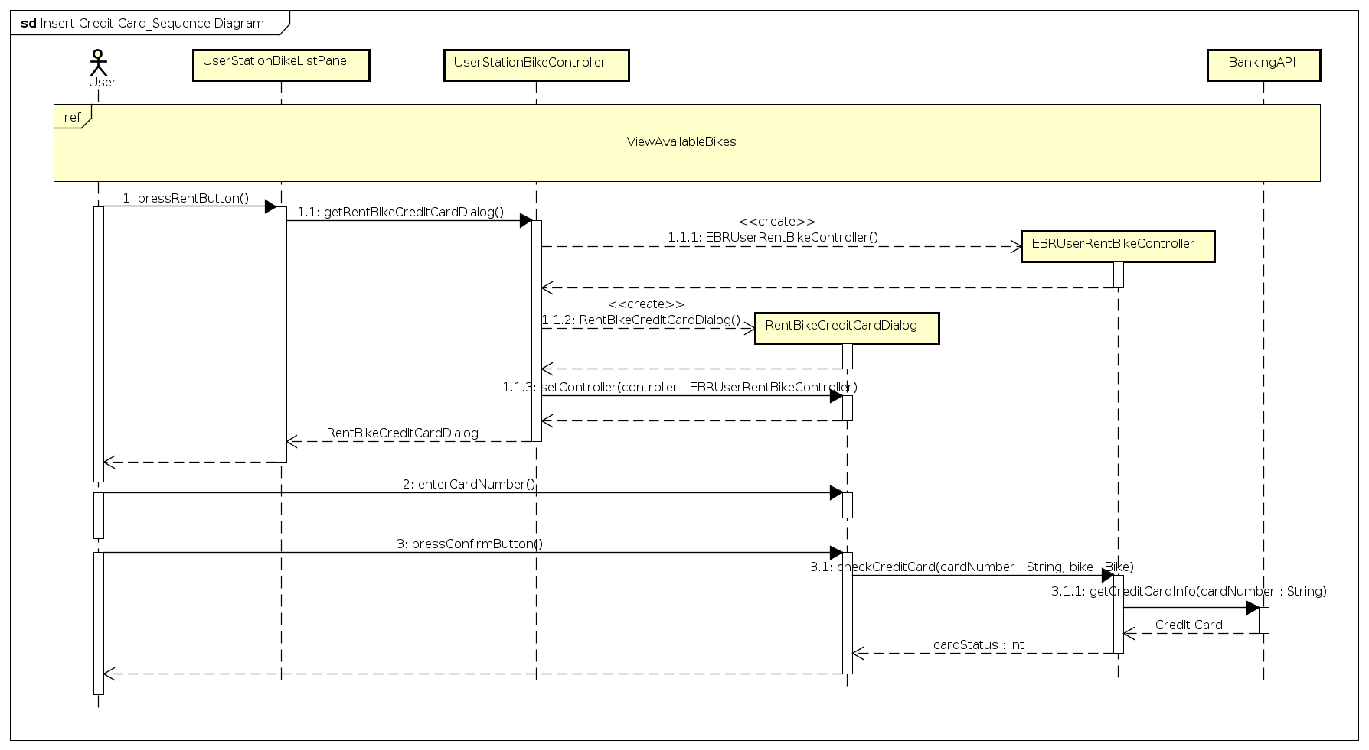

* 1. Design Classes

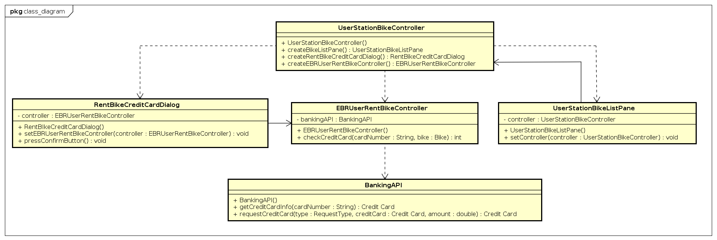

1. Unit Testing

|  |  |  |  |  |  |
| --- | --- | --- | --- | --- | --- |
| **Test Case Name:** Insert Credit Card | | | **Technique applied:** Black Box | | |
| **Description:** Test the card number | | | | | |
| **Pre-conditions:** Successfully to view available bikes in station | | | | | |
|  | | | | | |
| **Step** | **Action** | **Expected System Response** | | **Pass/Fails** | **Comment** |
| 1 | Enter ‘123’ in field and press confirm | Show dialog to prompt invalid card number | | pass |  |
| 2 | Enter ‘201768612017’ in field and press confirm | Show dialog to prompt card number unavailable | | Pass |  |
| 3 | Enter ‘201767642017’ in field and press confirm | Show dialog to prompt card does not have enough money to rent bike | | Pass |  |
| 4 | Enter ‘201702242017’ in field and press confirm | Perform next state | | Pass |  |